Introduction
This manual is intended for the person in charge of maintaining the WinS Monitoring System in the School. It contains instructions on how to input data, generate the reports, and upload the data into the online system.
The WinS Monitoring System is composed of the paper-based WinS Monitoring Form which will be accomplished by the schools, the Excel-Based WinS Monitoring System which will be used to encode data from the monitoring form, and the WinS Online Monitoring System which will be used to upload the data from the Excel-Based System and generate aggregated reports for use in the Division, Region and National Levels.
The latest versions of the Monitoring Form, Excel-Based System and Online Monitoring System can be accessed at http://deped-wins.sysdb.site.

Excel-based wins monitoring system
The Excel-Based WinS Monitoring System will be used to encode data from the monitoring form. The system can be opened using Excel 2007 and above. It was designed to function even without internet connection. It was also designed to provide feedback mechanisms that will help the school diagnose the quality of WinS implementation. Each school shall have one file containing data for one school year.

Entering data in the Excel-Based WinS Monitoring System
The data entry module of the Excel-Based System can be accessed by clicking on the “Entry” worksheet found in the lower left section of the screen. The user can only encode data in cells which are colored white. The user can click the “Tab” or “Enter” keys to move to the next cell in the system.
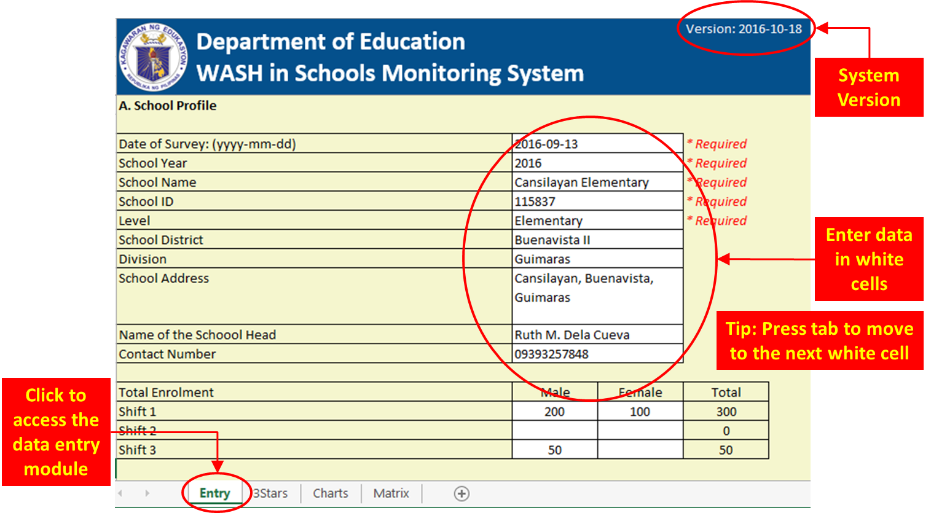

Certain cells in the system have predefined options which the user needs to select. To enter data for these cells, the user has to click on the dropdown arrow which will appear when the cell is activated and select the appropriate value. Entering invalid values will result in a message box warning the user that the data entered is not valid. In order to proceed with encoding the data, press the “Cancel” button and enter the correct data. There are also cells which require numeric values such as enrolment data. These cells will not accept letters or special characters.

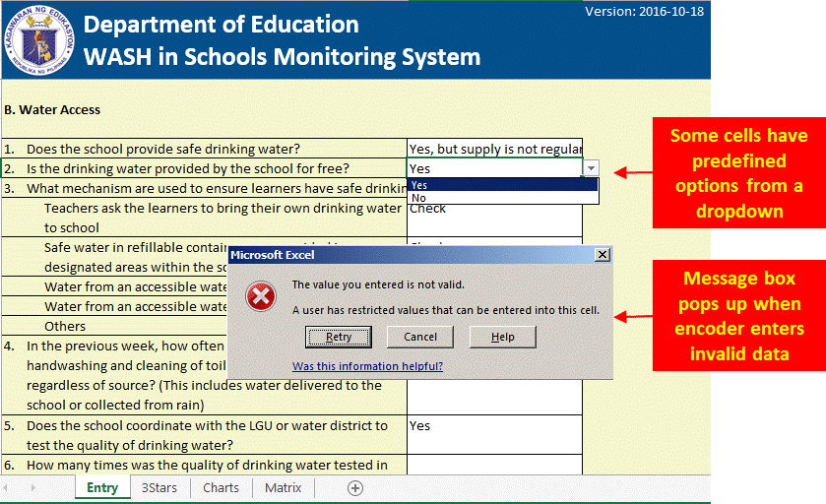

Accessing the Reports in the Excel-Based WinS Monitoring System

The WinS 3-Star Matrix for Schools can be accessed by clicking on the “Matrix” worksheet found in the lower left section of the screen. It provides an overview of how the school is performing in the 40 WinS indicators. The performance is color coded with Red being the lowest at 0 star, followed by Yellow at 1 star, Green at 2 stars and Blue at 3 stars. Ideally a school will target to move the lowest performing indicators to the next level in order to improve the quality of WinS implementation. Clicking on any of the indicators will bring the user to the WinS 3-Star Report for Schools which shows the detailed milestones that a school needs to achieve in order to reach the national standard at the third star. The results found in this report are based on the information encoded in the data entry module of the system.
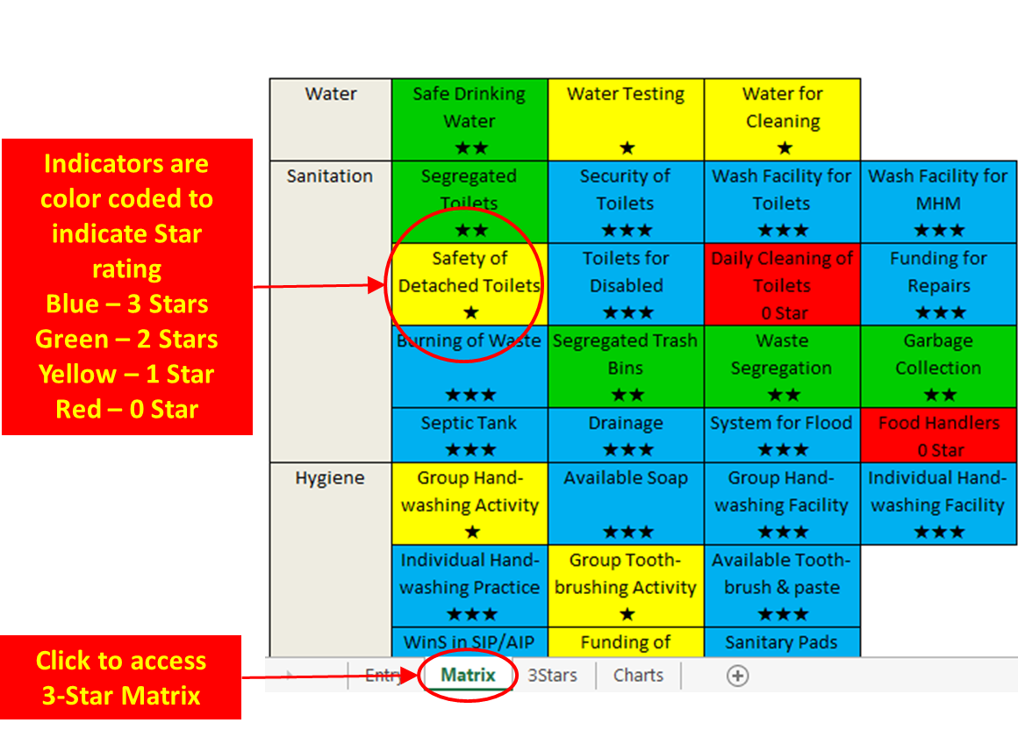

All the reports in the system have been protected from editing. If a user wants to print an edited version, copy the whole worksheet to a different file where you can make the appropriate revisions.

The WinS 3-Star Report for Schools can be access by clicking on the “3Stars” worksheet found in the lower left section of the screen. It provides a detailed view of all the 40 WinS indicators and the milestones that a school needs to achieve in order to reach the national standard. A check in the report would signify the rating for a particular indicator. In the example below, the school has already met the criteria for 2 stars for W.S1-1 which is the indicator for Safe Drinking Water. The system will automatically provide the scores for each of the indicators based on the data encoded in the data entry module and compute the overall rating of the school which, in this case, is one star.

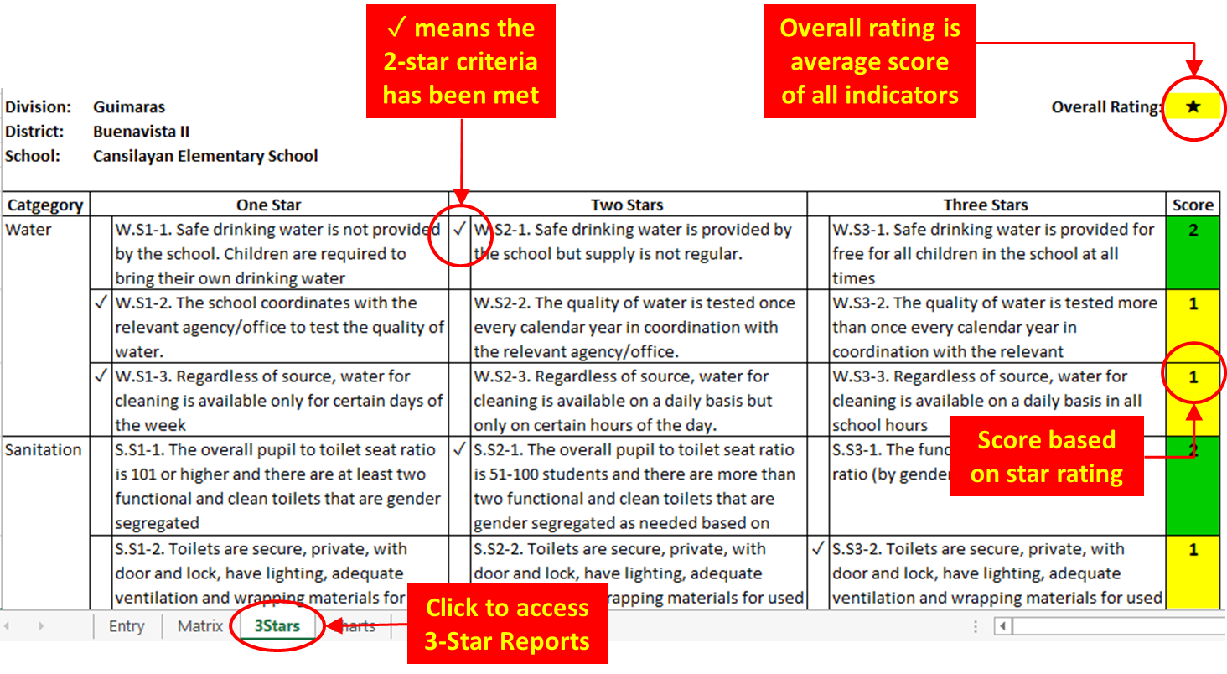

The basis for computing the overall rating is the average score of all the indicators matched against the continuum scale below. There are also 5 crucial indicators which are pre-requisites for a school to move beyond 0 star. The 5 crucial indicators are Safe Drinking Water, Gender-Segregated Toilets, Group Handwashing Facility, Group Handwashing Activities, and Access to Sanitary Pads. If a school scores 0 in any of the 5 crucial indicators, it shall automatically be a 0 star school regardless of its overall rating.

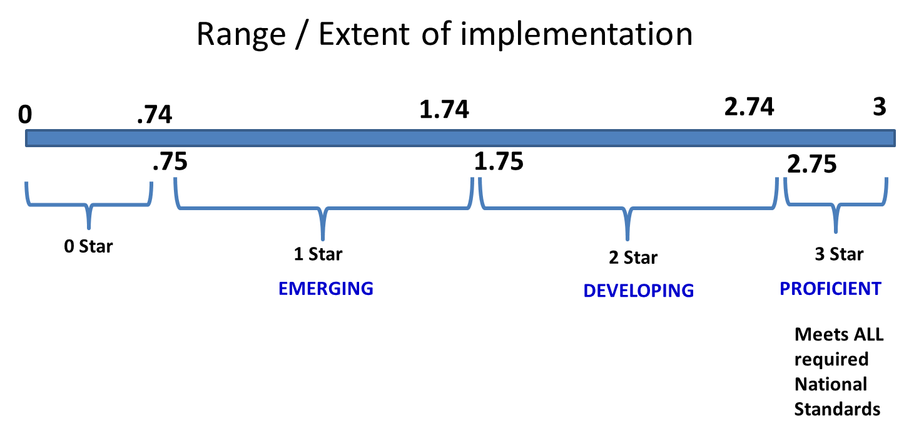
The WinS 3-Star Charts for Schools can be access by clicking on the “Charts” worksheet found in the lower left section of the screen. It provides the same information as the WinS 3-Star Matrix but in a more graphical view.
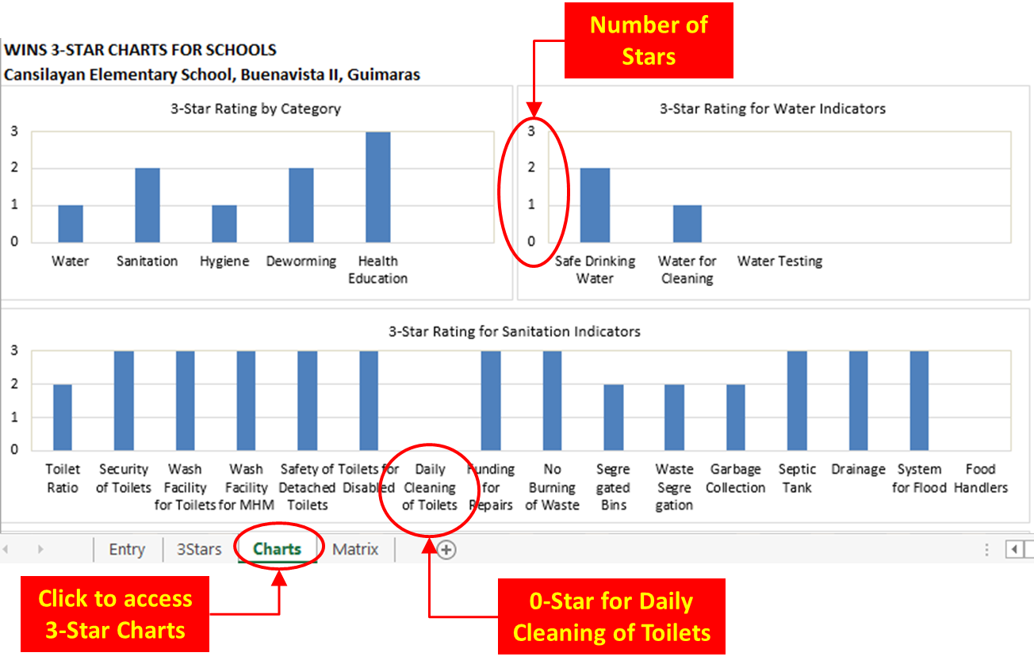

Uploading the Excel-based system to the Wins Online monitoring system

The online monitoring system can be accessed at http://deped-wins.sysdb.site. It was designed primarily to upload the Excel-Based System that was encoded by the schools and generate aggregated reports that will be useful to the Divisions, Regions and National levels.

Logging in
Accessing the website will bring the user to the Login Page. The user has to enter the appropriate username and password to access the various modules of the system. The username and password of the schools will be created and maintained by the Division IT Officer. Please contact your respective IT Officers if you still do not have a user account.
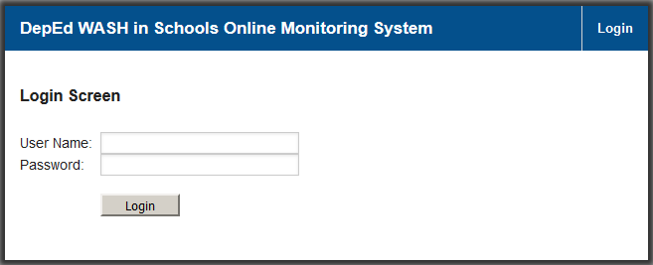

Accessing the Upload School System Module

Entering the correct username and password will give the user access to the various modules of the system. Move the mouse to the <Modules> Menu in the upper right section of the screen, then click the <Upload School System> command to access the Upload School System Screen.

When the Upload School System Screen appears, click on <Browse> then select the file containing the Excel-Based System for your school. Click on the <Upload> button to send the data into the online monitoring system. The system will display a confirmation message if the file was successfully uploaded. An error message will appear if the Excel System was not successfully uploaded.

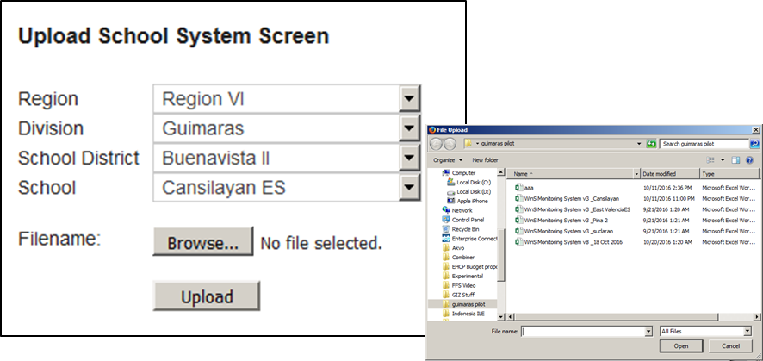

In cases where the school needs to make changes in the data, first update the Excel System then repeat the process of uploading the revised Excel System. This will overwrite the old data with the new one. The school can make changes in the online monitoring system as long as data for the school year has not yet been finalized.

Helpdesk

For inquiries regarding the system please contact deped.wins.help@gmail.com.

